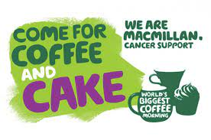
Colham Manor Primary School

We raised £353 for Macmillan Cancer Support!

