
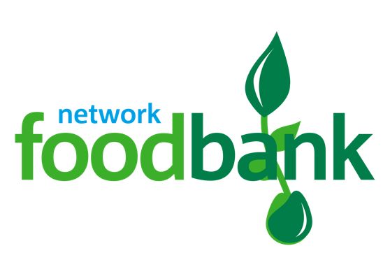
Your donation of 315.6 kg of food(16 emergency family food parcel or 64 bags of food) makes a BIG difference
to local people in crisis.
Hillingdon foodbank is part of the Trussell Trust’s UK wide foodbank network.
Colham Manor Primary School
for supporting Hillingdon foodbank.

Registered Charity Number: 1148148 | Registered in England and Wales

